3.50: The bird’s tangential velocity can be found from
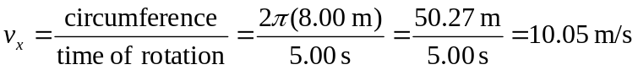
Thus its velocity consists of the components 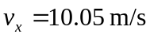 and 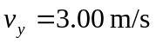. The speed relative to the ground is then
(b) The bird’s speed is constant, so its acceleration is strictly centripetal–entirely in the horizontal direction, toward the center of its spiral path–and has magnitude
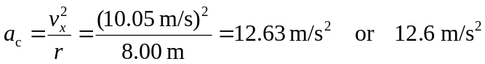
(c) Using the vertical and horizontal velocity components:
